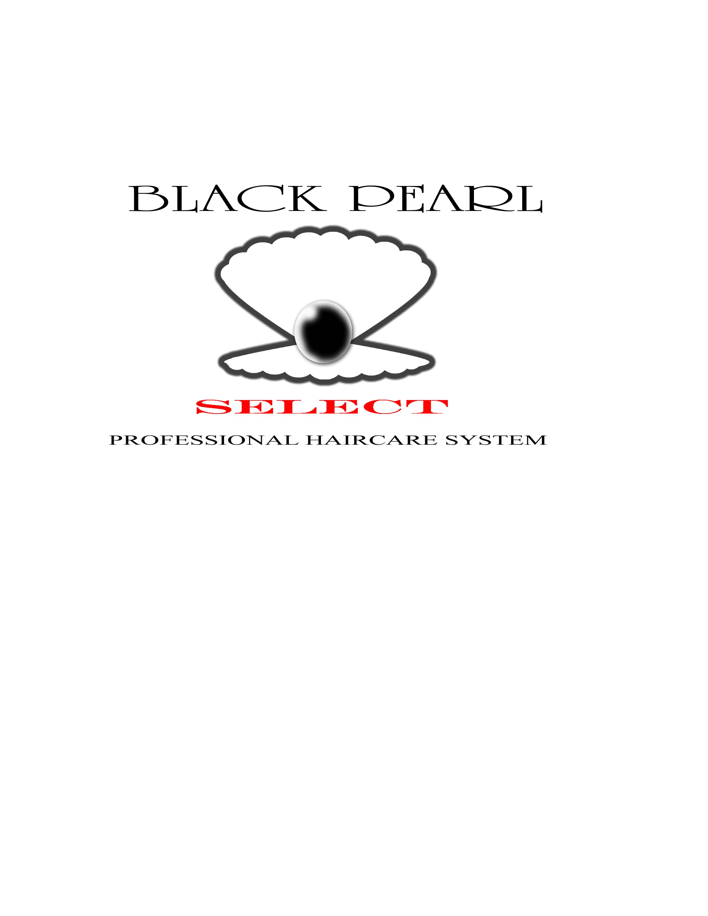
It’s That Time Again!!
Black Pearl Selects 5th Annual Comedy Luau
Sponsored by
Black Pearl Select Beauty Salon & Products
&
The Joe Johnson Foundation

Date: Saturday, July 11, 2009
Time: Gates open at 10:00 am
Place: Cahaba Shrine Park, 6001 Pulaski Pike, Huntsville, Alabama 35810
Please! No alcohol allowed on premises.

The Story – How it all Began
For over 13 years, Alvin Hargrove (aka “Pearl”) and Vic Love of the BPS Beauty Salon have been serving Madison and its surrounding counties here in Huntsville, Alabama. Their work testifies of the true meaning of “Giving Back to the Community”.
These “Gentle Giants” have sponsored:
- Tutorial programs
- Served the NYSP (National Youth Sports Program)
- Provided Out Reach Services to the residents of local Nursing Homes
- Made donations (Electronic Equipment, etc) to one of Huntsville’s City Elementary Schools
- Provided “Easter Hair Cuts” to children in the community (copy of coverage at WHNTTV.com)
They also use their personal lawn equipment to mow lawns of the elderly and the needy.
Pearl and Vic’s motto can be found in Luke 6:38, “Give and it shall be given unto you good measures pressed down shaken together and running over”.
You can help them give back to you and your community this year by one of the following methods:
- Purchase one of the Sponsorship Packages – If you are a business owner, consider being a sponsor
- Purchase a Vendor Package – Promote/Advertise your business services and/or products by renting a booth.
- Purchase one of the Group Organization Packages – City, church and other community organizations are encouraged to participate, children and older adults included.
A portion of the proceeds will be donated to The Muscular Dystrophy Association and other charitable events such as free community cuts for children on certain holidays and free back to school haircuts. These and several other donations are all sponsored by Black Pearl Select Beauty Salon & Products.
Please view the enclosed information on packages for your organization’s groups and ministries. For more information, please visit our website at www.blackpearlselect.com.
Contact numbers: (256) 417-7609, (256) 797-0746, or (256) 536-3133.
Group Package Options*, **, ***, ****, *****
(group size includes adults and children)

- Groups of size 30 - Cost is $240
- Groups of size 50 - Cost is $400
- Groups of size 75 - Cost is $600
- Groups of size 100 - Cost is $800
- Groups of over 100 - Please call
* All rides(trackless train, electronic swings, etc) and inflatables are free for children.
**Meals are $3 per person and include choice of meat, chips and soda. Select group time to eat (11:00am, 11:30am, 12:30pm, 1:00pm, 1:30pm, 2:00pm, 2:30pm, on your own)
***Group packages include 5 complimentary game tickets for each child.
****Games and other attractions require small fee, not to exceed $3 such as arts crafts for $3 for materials, dunking booth for $1, etc.
*****Groups are encouraged to provide own tents, tables and chairs to reduce additional costs and ensure seating for all. Please set up on event day by 9:30a. If additional tents, tables, and chairs are needed, please notify us by calling one of the numbers listed.
General Admission
$10.00 per adult (18 years and up) with up to 5 children 17 years and younger (children enter free)
$3.00 per meal - includes choice of meat, chips, soda

$7.00 per adult (70 years and up)
$2.00 per meal – includes choice of meat, chips, soda or water

Adults 70 years and up are welcomed and strongly encouraged to attend. If wheelchairs and walkers are used, please call to confirm accessibility. Games provided such bingo, checkers, cards and dominos for hours and hours of fun.

Luau Photo Opportunities
Luau photo opportunities will be provided with the infamous Black Pearl & Vic, and with an NBA Player of the Atlanta Hawks. Cost is $10 and includes both photos. Photos may be available after purchase (time permitting) or will be mailed within 1-2 weeks of the Luau. They will be added to the photo gallery at www.blackpearlselect.com.
Atlanta Hawk Give-A-Ways while supplies last
Complete the form below and return to the address listed. We look forward to seeing you!
PLEASE PRINT AND RETURN WITH GROUP PAYMENT
--------------------------------------------------------------------------------------------------------------------------------------------------------

Group Packages include all rides & inflatables free for children and 5 complimentary game tickets for each child. Games and other attractions require small fee, not to exceed $3 such as arts crafts for $3 for materials, dunking booth for $1, etc. Groups are encouraged to provide own tents, tables and chairs to reduce additional costs and ensure seating for all. Please set up on event day by 9:30a. If additional tents, tables, and chairs are needed, please notify us by calling (256) 417-7609, (256) 797-0746, or (256) 536-3133. Deadline for submissions and payment is Wednesday, July 8, 2009 (postmarked).

Group Package Size ___________________________________________________________
Group/Ministry Name________________________________________________________
Organization/Church Name____________________________________________________
Eating Time _11:00am, 11:30am, 12:30pm, 1:00pm, 1:30pm, 2:00pm, 2:30pm, Eat on Own_
Point of Contact _____________________________________________________________
Address____________________________________________________________________
Phone_____________________________________________________________________
Email_____________________________________________________________________
Amount enclosed $_____________
Make Check/Money Order Payable to: Black Pearl Select – Comedy Luau 2009

Complete this portion and mail to:
Black Pearl Select Salons
2908 Meridian Street, Suite A
Huntsville, AL 35811
An email confirmation will be sent upon receipt

